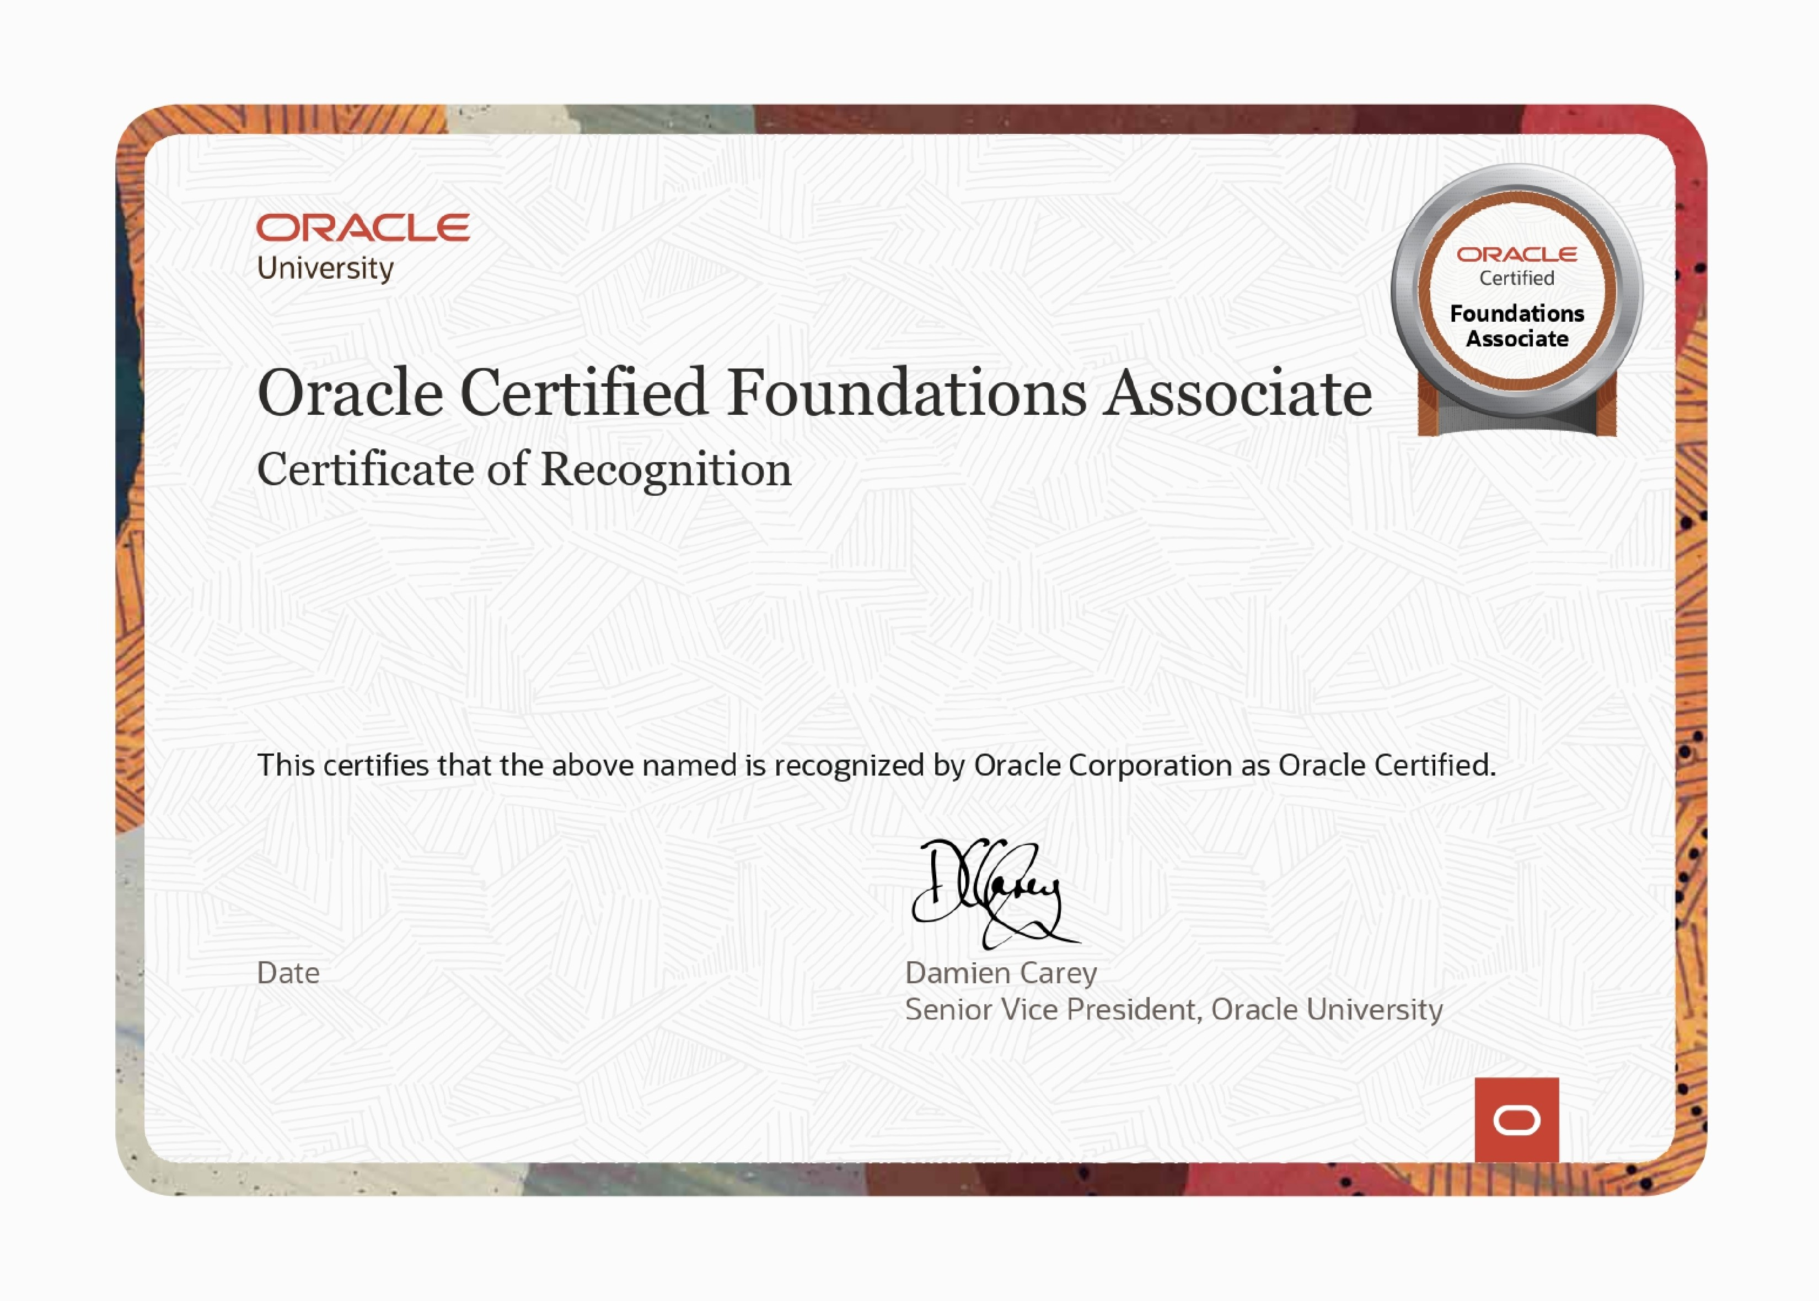

Suresh P.B

Oracle Cloud Infrastructure 2025 Certified AI Foundations Associate

May 14, 2025

This eCertificate is valid until May 14, 2027

101322128OCI25

AICFA